OUR TIME

Synopsis

In a city park, ten teenagers are caught up in a social-media frenzy of talking, texting, and taunting. Diana, a parent, is overwhelmed by the spoiled children, and other parents join her in their concern. The children begin to rebel, and the conflict between parents and kids is heightened.

Breaking free, the children travel to New York, where they experience the daunting crowds. The parents reassure them and give confidence, but in doing so they take on the children’s uneasiness.

The children audition on Broadway for a production of *Godspell*, with LeeAnn as the casting director. Competing groups vie for just a few coveted roles. Those who are cast perform a number from the show, but those who are eliminated have their own say, crashing the performance.

In the end, parents and children reunite, and all recognize the value of hard work, confidence, and understanding.

Cast/Students  
(in order of appearance)

Diana Renata Sommer  
Quinn Nina Sogor  
Fiona Sarah Castillo  
Micky Moira Sogor  
LeeAnn Catherine Cui  
Ariel Sabrina Wong  
Isabel Ayla Christiansen  
Jordan Kaye Lau  
Sam Theo Sommer  
Raven Susan He  
Zach Darren Zhang

Musical Numbers

“OMG!” Written for this production by Seth Weinstein  
“BRIMSTONE AND TREACLE” *Mary Poppins*  
 Robert B. Sherman, Richard M. Sherman,  
 George Stiles, Anthony Drewe  
“LITTLE GIRLS” *Annie*  
 Music: Charles Strouse/Lyrics: Martin Charnin  
“OLIVER” *Oliver!*  
 Lionel Bart  
“AQUARIUS” *Hair*  
 Music: Galt MacDermot/Lyrics: James Rado, Gerome Ragni  
“MAMA, I’M A BIG GIRL NOW” *Hairspray*  
 Music: Marc Shaiman/Lyrics: Scott Wittman, Marc Shaiman  
“KIDS!” *Bye Bye Birdie*  
 Music: Charles Strouse/Lyrics: Lee Adams  
“THERE’S GOTTA BE SOMETHING BETTER” *Sweet Charity*  
 Music: Cy Coleman/Lyrics: Dorothy Fields  
“ANOTHER HUNDRED PEOPLE” *Company*  
 Stephen Sondheim  
“I HAVE CONFIDENCE” *The Sound of Music*  
 Music: Richard Rodgers/Lyrics: Oscar Hammerstein II  
“I HOPE I GET IT” *A Chorus Line*  
 Music: Marvin Hamlisch/Lyrics: Edward Kleban  
“THE LIGHTS OF BROADWAY” *The Wild Party*  
 Michael John LaChiusa  
“HARD WORK” *Fame*  
 Music: Steve Margoshes/Lyrics: Jacques Levy  
“ALL FOR THE BEST” *Godspell*  
 Stephen Schwartz  
“I WON’T GROW UP” *Peter Pan*  
 Music: Moose Charlap, Jule Styne/  
 Lyrics: Carolyn Leigh, Betty Comden, Adolph Green  
“NAUGHTY” *Matilda*  
 Tim Minchin  
“MY SHOT” *Hamilton*  
 Lin-Manuel Miranda

StudentsLive/Passport to Broadway

Amy Weinstein, Artistic Director and Director

Seth Weinstein, Musical Director

Gabriella Zimányi, Choreographer

Renata Sommer, Production Coordinator  
and Marketing Associate

Jessica Fraser, General Manager

Derek Luebbe and Laurie Luebbe, Presenting Partners

Special Thanks

Justin

Mikael Masson

***StudentsLive*** has begun to develop audiences outside the United States with **Passport to Broadway – An International and Domestic Musical Theater Program**, a customizable and ultimate Broadway Education experience presented by our company for students of all ages.  Thisis being developed to bring international and domestic young people and students to New York City as well as ***StudentsLive*** traveling to their specific locales and countries for the opportunity of a lifetime.

The ***StudentsLive*** **Passport to Broadway Program** ([www.passporttobroadway.com](http://www.passporttobroadway.com/)) allows students the opportunity to experience, first hand, the best live, Broadway interactive theater education programs, taught by the best, highly trained Broadway specialists, our country has to offer. The program allows students to experience the intensive training of a professional, successful and highly disciplined Broadway Artist and the myriad skills required in collaboration, interrelation, communication and human exploration. The goals are to expand and deepen students understanding and familiarity with all areas of Broadway Theater and to enhance their studies in human behavior, culture, intention and expression.  Through challenging music, dance, acting and, most importantly, the unique art form of “putting it all together”, taught by the best professionals on Broadway, ***StudentsLive*** prepares students to be highly competitive in whatever career they choose to pursue as well as prepare for the best universities and career opportunities possible.

Through ***StudentsLive’s*** **Passport to Broadway Program**, ***StudentsLive*** provides international and domestic high school and college students with the invaluable resources and insights to becoming a serious actor/performer in New York and worldwide.  During the course of ***StudentsLive’s*** time with the students, they broaden their knowledge of the importance of performance studies combining choreography, voice, and acting to achieve the skills of a “triple threat” and increase their competitive ability and skills in the Broadway Industry. At the end of the course the students perform a live, original “Broadway Show” for a select and invited audience of top-tier Broadway Professionals. In this intensive, students will also be exposed to the invaluable and often inaccessible resources New York Broadway Theater has to offer.

As part of the **Program**, participants experience Broadway like never before - by working with top Broadway Professionals as they rehearse and perform a specially composed medley of 40 quintessential Broadway songs that span the entire history of musical theater in the United States.  For one, two or three weeks (there are 3, 5, 10 and 18-day programs), participants work every day with a Director,  Broadway Choreographer, Dance Captain, and Musical Director, and meet with specially invited Broadway Guest Professionals who can illuminate students' understanding of their particular field of expertise in musical theater.

**Passport to Broadway International**

353 West 48th Street, Suite 336, New York, NY 10036

Phone: 011-212-220-6000, Fax: 646-619-4276, Email: [info@studentslive.net](mailto:info@studentslive.net)

Shanghai Contact: **Renata Simaika, Marketing Associate** [renatabs@hotmail.com](mailto:renatabs@hotmail.com)

If you have any questions, or would like more information on any of the above mentioned programs and opportunities, please see our **Twitter** [@PassportToBway](https://twitter.com/@PassportToBway) or our website [www.passporttobroadway.com](http://www.passporttobroadway.com/).

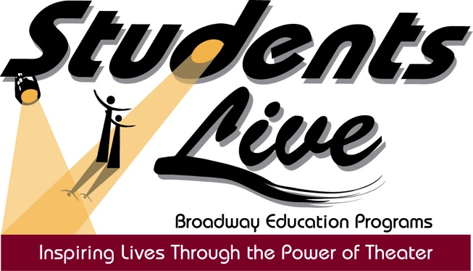

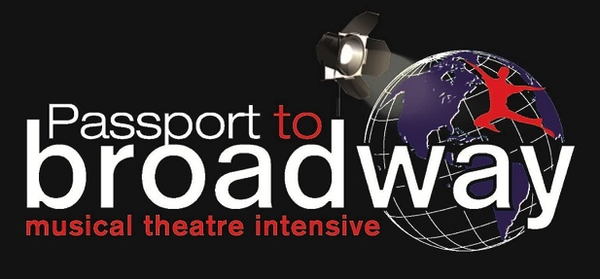

https://cdn.scischina.org/assets/img/logo-white-no-campus@60px-height.png

“OUR TIME”

Shanghai Community International School

August 10, 2018